**BUREAU OF PLANT INDUSTRY MANAGEMENT SYSTEM**

**Chapter I**

**Introduction**

Nowadays many companies built their own system to have fast and easy works. They depend on the technology to support their work and have a continuous work with less expenses. Companies use a system to manipulate works and guide people to do their tasks assigned to them. Many companies rely on systems because it will support the job and activities to have a productive service.

In the company of Bureau Plant Industry located in Barangay La Granja, La Carlota City have only a manual system to manipulate their works. The work of BPI only uses a basic checking plant and also it will write only in a paper or book to keep the gathered data safe. Some worker has a hard time to do their job because of handling plant problem. They analyze and do a brainstorming to know what is the cause of plant problem. When they keep the data's they use paper or book and it can cause lost or problem to other workers to find the old document to give a basis in the new crops. They have a hard time to analyze and understand some important old details because some of the letters are faded.

The BPI workers can feel tiredness because of so many plant to check and list it all in paper or book. Using paper and book to keep the data of BPI is applicable but it is not secure when it lost or wet because of accidentally doing mistake. So that we came up to a solution in creating a computerized system, help them by upgrade their system and secured.

**General Objectives**

This study aims to provide concrete and fast service to support the activities of the Bureau of Plant Industry Management System. The system promotes and enhance the service by using a computerized and easy to manage to the user.

**Specific Objectives**

The Specific Objectives of the study are the following:

* To develop the Bureau of Plant Industry Management System to aims and promote the job of workers using android device to do the checking of plant.
* To manage the system also provides a specific information about the data of BPI in any types of plants and costumer data.
* To develop the system to aims and provide security on the data of BPI.
* To monitor the system will support also a Decision Support System to provide solution to the plant problem of BPI and forecasting the number of crops harvest.

**Purpose and Description**

The purpose of the proponent is to help the Bureau of Plant Industry in terms of checking and monitoring plant. The system will help to guide the workers in the problem of plants and information. The secretary can look out if there a stock of harvest fruits and vegetable to sell to the costumer. The system will provide a decision support system to the problem of plant and also it will support on the forecasting the numbers of harvest in fruits and vegetables. The system has a server to store the data when the workers send a data after checking all plants.

**Scope and Limitation**

The Bureau of Plant Industry Management System is intended only to the admin/owner, secretary and worker. The system will focus only on checking plant and support a solution to the plant problem by the use of Decision Support System. It will focus on viewing available crops, records of costumer who buy a crops and also all plant information.

**Significance of the Study**

***BPI Corporation:*** This system will provide an information of the product to the customer and convenience in knowing the profile of the customer who wants to buy product.

***Brgy. La Granja Workers:***  To easy the task and help the BPI company improve the production of plant.

***Future Researcher:*** This will serve as reference to the future researcher if they to continue this study. This also give them a knowledge in creating and developing the system.

**Definition of terms**

For the clarification of the particular word used in the proposed system, the key word that has been used in this study will be defined as follow.

***Administrator:*** In the dictionary, it refers to a person whose job is to manage a company, school, or other organization but in this study, it refers to the one who will receive the information and will give remarks in every transaction.

***Customer:***  In the dictionary, it is someone who buys goods or services from a business but in this study, it’s refers does not share any of its resources that request a server’s content or service function.

***Decision Support System:*** This term is support business or organization decision making activities it served management operation and planning level of organization and help to make decision.

***Hardware:*** In the dictionary, it is referring to a thing (such as tools or parts of machines) that are made of metal but in this study it is refers to the computer equipment used to perform the transaction of the system.

***Record:*** In the dictionary, it is referring to write (something) down so that it can be used or seen again in the future but in this study it is the collection of related files with information that usually pertains to one products.

***Software:*** In the dictionary, it is referring to the program that run on a computer and perform certain functions but in this study, it is refers to a system utility or application program expressed in complete readable language.

**CHAPTER II**

**Review of Related Literature and PPIOR ARTS**

This chapter present the reviews of related works and study deals in creating inventory. The concept of this chapter is to provide multiple articles from different source where used to familiarize and to authenticate the needed data for the study.

**Related Concept**

The proponent conducts a research about the related literature and prior arts through book and internet that are applicable in the development of the system.

**Local Related Literature**

**Bureau of Plant Industry in Davao, Philippines**

According to Bago Oshiro, Davao City year of 2014 the Davao National Crop Research, Development and Production Support Center, formerly known as the Davao Experiment Station located in Bago Oshiro, Tugbok District, Davao City was one of the first experimental stations operated by the defunct Fiber Division of the Bureau of Plant Industry. The station was charged mainly with the solution of the problems of the abaca industry in Mindanao.

In the pre-war years, the station was called the Bago Experimental Farm of the OTHA Development Company, a Japanese owned corporation with the idea of modernizing the cultivation of abaca in Davao. The project did not progress until the corporation established the Bago Experiment Station. The program of activities of the station gradually expanded. Experiments were not only focused on coconut, abaca and ramie but also to other crops such as citrus, pilinuts, durian, mabolo, rambutan, chico, marang, lychee, mangoes, star apple, Arabica coffee, African oil palm, black pepper and rubber. The station received technical and financial aids from both the Ministry of Industry of Japan and the General’s Office of Formosa. The station was intended to become the center for the improvement of agricultural technology in Southeast Asia.

This study is similar to the proposed system because they aimed to develop the production of plant and maintain the good harvest by creating a specific system. It focusses on the plant experiment to enhance and increase the production of harvest.

**Bureau of Plant Industry in Los Banos,Philippines**

According to the Bureau of Plant Industry in Los Banos City year of 2016

The Los Baños National Crop Research, Development, and Production Support Center (LBNCRDC) of the Bureau of Plant Industry was established on November 20, 1931 by virtue of Passage Act No. 3910 of the pre-independence Philippine Legislature. Formerly known as Los Baños Economic Garden, it was formally inaugurated in 1933 by Dr. Edwin Copeland, founder and first dean of the UP College of Agriculture. During the reorganization of the Department of Agriculture on July 1, 1988, the station was renamed Los Baños National Crop Research and Development Center as per Executive Order No. 116. The Center assumed its current name by virtue of Executive Order No. 366.

To make an Increase farmers productivity/profitability and in alleviation of poverty through crop research, production of high quality seeds and planting materials and transfer of developed technologies. Spearheads the development of improved varieties and other technologies for lowland vegetable and other horticultural crops; production of high quality seeds of various crops and plant materials of fruit trees and ornamentals; and transfer of developed technologies to the farming clientele. Generate and promote relevant technologies for lowland vegetables and other horticultural crops. Production of quality seeds and plant materials

Transfer of generated technologies to increase farmers' productivity and attain food security of the farming communities.

This study is similar to the proposed system because it focuses on the benefits of plant to become a good production of plant. This study aims to develop a technology to enhance the work and increase the plant production.

**Inventory and Monitoring Stock Management System**

According to Warren R. Planret in (2014) the Inventory is one of the most important in monitoring a stock that take place in business activity. The inventory system does the entire task in computing the value with inventory (cost and quality) and handling data or information. Inventory System maintains an orderly flow of supplies, raw materials, or finished goods through an office shop/factory because of items in any inventory. Represents cost, they need to be controlled. The purpose of inventory system for management are to keep inventory levels and cost at desire minimums while maintaining to proper safeguards over materials to places and people who need them. Inventory review refers to the time interval between counting inventories. Periodic review systems have a set schedule for conducting an inventory count. Transactional review systems update the inventory count after each transaction. Periodic review is less resource intensive but more prone to creating shortages and inventory discrepancies while transactional review is more accurate but requires more resources. Inventory costs can be broken into several categories: the actual cost of the inventoried product, the cost of storage and the cost of unmet demand if inventory is not available to fill orders. Additional costs include transportation and ordering costs incurred when replenishing inventory. Each of these costs is unique to individual businesses and can vary widely. (Warren R. Planret, 2014)

Inventory means goods and materials, or those goods and materials themselves, held available in stock by a business. This word is also used for a list of the contents of a household and for a list for testamentary purposes of the possessions of someone who has died. In accounting, inventory is considered an asset. Inventory proportionality is the goal of demand-driven inventory management.

The study is similar to the proposed system because it developed the process of stock to make

**Foreign Related Literature System**

**Computerized Inventory Management System**

According to Thomas M. Mchugh (2013) the Inventory control systems maintain information about activities within firms that ensure the delivery of products to customers. The subsystems that perform these functions include sales, manufacturing, warehousing, ordering, and receiving. In different firms the activities associated with each of these areas may not be strictly contained within separate subsystems, but these functions must be performed in sequence in order to have a well-run inventory control system.

In today's business environment, even small and mid-sized businesses have come to rely on computerized inventory management systems. Certainly, there are plenty of small retail outlets, manufacturers, and other businesses that continue to rely on manual means of inventory tracking. Indeed, for some small businesses, like convenience stores, shoe stores, or nurseries, purchase of an electronic inventory tracking system might constitute a wasteful use of financial resources. But for other firms operating in industries that feature high volume turnover of raw materials and/or finished products, computerized tracking systems have emerged as a key component of business strategies aimed at increasing productivity and maintaining competitiveness. Moreover, the recent development of powerful computer programs capable of addressing a wide variety of record keeping needs—including inventory management in one integrated system have also contributed to the growing popularity of electronic inventory control options.

Given such developments, it is little wonder that business experts commonly cite inventory management as a vital element that can spell the difference between success and failure in today's keenly competitive business world. Writing in production and Inventory Management Journal, Godwin Udo described telecommunications technology as a critical organizational asset that can help a company realize important competitive gains in the area of inventory management. He noted that companies that make good use of this technology are far better equipped to succeed than those who rely on outdated or unwieldy methods of inventory control.

**INVENTORY MANAGEMENT (JIT AND BLACKFLUSH COSTING)**

According to Dr. James Collins in June 13, 2014 the Inventory Management includes planning, coordination, and controlling the flow of inventory into, though, and out of company. There are 5 categories of cost that are associated with goods sold: Purchasing costs: the cost of goods from supplier and freight Ordering costs: the cost of preparing purchase orders, receiving and checking the goods, matching invoices received, purchase orders and delivery notes to make payments. Storage cost: the cost of holding inventory of goods sale. Stock out costs: the cost is incurred when the company ran out of certain items that are requested by customer Quality costs: the cost is incurred if the features and characteristics of the product are not in accordance with customer. Economic Order Quantity is a decision model to calculate the optimal quantity of inventory to be ordered with certain assumptions. That assumption is simply no booking fees, storage, same quantity ordered on each reorder point, demand, charge ordering, and storage costs are already known with certainty, the purchase cost per unit is not affected by the quantity ordered, and do not occur out of stock.

**Bureau Of Plant Industry in Korea,International**

According to DA Secretary Emmanuel F.Pinol (Korea Rural Development Administration in year of 2018 the KOREA PROGRAM ON INTERNATIONAL AGRICULTURE (KOPIA) Center - Philippines, now located at the Bureau of Plant Industry Los Banos National Crop Research, Development and Production Support Center (BPI-LBNCRDPSC) in Economic Garden, Timugan, Los Banos, Laguna was inaugurated on August 30, 2018. Present during the momentous event were DA Secretary Emmanuel F. Piñol, Korea’s Rural Development Administration (RDA) Vice Administrator Kyu Seong Lee, BPI OIC Director George Y. Culaste, KOPIA Center – Philippines Director Dr. Jeong Taek Lee, DA Undersecretary of HVCDP and Rural Credit Evelyn Laviña, International Cooperation Bureau Director General Dr. Ji Won Lee, Laguna Provincial Agriculturist Marlon Tobias, and Minister Counselor of the Koran Embassy of the Philippines Ms. Sun Young Kim, and farmers representatives from nearby municipalities.

KOPIA has been assisting developing countries by working closely with partner country on the development of various kinds of cooperative projects and transfer of agricultural technologies in the improvement of agricultural productivity and farmers’ income since 2009.

KOPIA Center in the Philippines was established and located at PhilRice in Munoz City in 2010. The Center carried out different agricultural productivity projects with special focus on rice since then. The project facilitated participating farmers to adopt best practices such as mechanization, organization of agricultural cooperatives and utilization of funds. Memorandum of Agreement (MOA) between KOPIA and DA was signed. BPI-LBNCRDSC will now be the home of KOPIA Center. The relocation is expected to develop closer linkages and collaboration of Korean government entities in the country and many agricultural institutions which are in Los Baños. BPI and KOPIA will collaborate on the development of technologies from rice to different variety of crops like mushroom, leafy vegetables, mung beans and garlics. These are expected to contribute to better productivity and help increase income of small farmers.

KOPIA’s slogan “We love to share what we have experienced” is its driving force to carry out projects with partner institutions to meet the needs of each country like the Philippines.

This study is similar to the proposed system because it provides an information about in the plant to monitor and give a basis on how the plant will have a good production. It supports the plant in terms of propagation of plant and growing phase.

|  |  |  |  |  |  |  |
| --- | --- | --- | --- | --- | --- | --- |
| Related  Prior Arts | Features | | | | | |
|  | User  Friendly | Connectivity | Scheduling | Web-Base | Time Tabling | Security |
| Inventory and Monitoring Stock Management  System | Yes | Offline |  |  |  | Yes |
| Computerized Inventory Management System | Yes | Offline |  |  |  | Yes |
| Inventory Management (JIT AND BLACKFLUSH COSTING) | Yes | Offline |  |  |  | Yes |
|  |  |  |  |  |  |  |
|  |  |  |  |  |  |  |

**CHAPTER III**

**Research Design and Methodology**

**Research Design**

The researchers use a specific method to propose a developing system. The system collects all the data and insert in database to materialize. Some function categorizes in analysis and gathering all information on what is being presented and being show in the program. The BPI Management System is an agile project delivery framework, initially used a software development method and used also application to collect all the data. The proposal of this system is to enhance the work and effective assignment on how to work fast and analyze the data. The used of application is to enhance and fast gathered of information using your android phone or tablet to send in the server. The effectiveness of database is to store data and used as a bases of information to upgrade the work of BPI. The framework of the system categorizes the function of BPI on how to make a fast transaction between the application and server, it is cover a wide range of activities to cover the cycle of work and processes.

**Project Development**

The BPI project development is beginning with the planning phase where the developers discusses the requirement of the application and system that are needed to develop the project. In designing the project, the proponent discusses what should be the appropriate design to be fit on the develop project. The proponent agreed that the interface of the develop project must be accurate to the BPI corporation. The proponent used a basic design to understand the project or the system that used someday. The proponent agreed to use a simple framework work to interpret the main objectives of the project. This is also having a great impact to the management to use this system because it is easy to handle and the function of system can understand by the user.

**Spiral Model Devilopment Life Cycle**

Spiral model is a combination of sequential and prototype model. This model is best used for large projects which involves continuous enhancements. There are specific activities which are done in one iteration (spiral) where the output is a small prototype of the large software. The same activities are then repeated for all the spirals till the entire software is build.

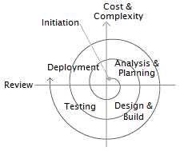

*Figure 1: Spiral Model*

Figure 1 display the process of software development that should be done in order to reach the satisfaction level of a developed system. The Spiral Model Development Life Cycle has seven phases to needed to complete the developed system.

**Analysis and Planning**

In analysis, the proponent conducts a research and interview on the staff of BPI. The proponent know that they do manual checking of the plant. The proponent discusses about the problem on the BPI and give solution, they give appropriate framework and software processes to provide an easy work to them.

**Design and Build**

In this phase the proponent now uses the information that gathered to create an effective and user friendly framework. By the use of development tools proponent going to start to create the structure and function of the system.

**Testing**

This phase the framework was being test by the proponents to check if it is effective and functional to determine wither the system meet the desired requirement of the end-user.

**Deployment**

In this phase the deployment of the system follows and the new created system will be installed in the process. The user will have trained to be guide on how to use the system. The system will give to client and the proponent evaluate the process.

**Cost and Complexity**

After the proponent collect the information. They plan and discuss the processes of the system, also do searching and interview that cost of financial aspect. They give time and effort for the development of the system to accurate the desire need of the end-user.

**Review**

As every step is done the proponent review and check the feature and function of the system. They analyze if have problems and errors to change or replace some feature and function to make sure that the system work normally.

**Context Diagram**

**C**ontext diagram show the original flow of process of the developed process where an entity concerned is connected to a one main process. It also portrays the general input requirements and its process output.

Workers

Admin

Input data of plant in adding new crops and also costumer who reserved to buy a crops

Provide information about plant problem, number of harvest crops and also support solution to the plant problem

Show the information of plant and provide solution to the problem of plant

Input data of plant after checking

0

BPI Management System

*Figure 2: Context Diagram of BPI Management System*

Figure 2 show the general process of the developed system. It also demonstrates the input needed to be fill up of the administrator and also workers. The process of output of the system is intended to be exact and accurate to the needs of administrator and workers. All the concept of the study is applied to this diagram to help the management in having and accurate result in terms of providing information of plants and data of costumers.

**Data Flow Diagram**

The data flow diagram illustrates the flow of data, input requirements and process output of the developed system.

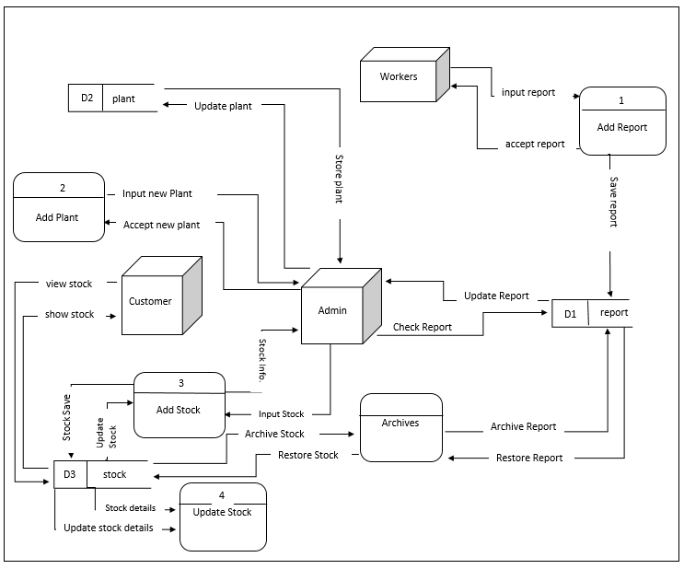

*Figure 3: Data Flow Diagram of Bureau of Plant Industry Management System*

Figure 3 show the entire data flow, the process, input requirements process output and the storage of developed system.

**Use Case Diagram**

This use case diagram shows the user’s interaction with the system and its relationship between different use case and the user is involved.

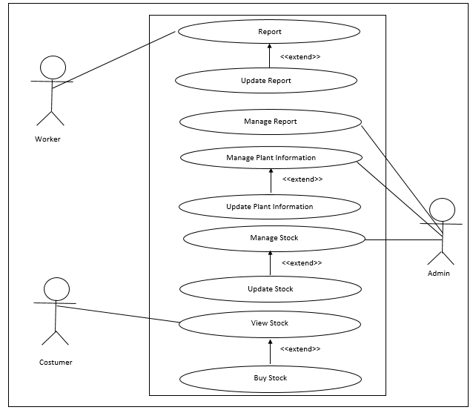

*Figure 4: Use Case Diagram of the Proponent Developed System*

**Use Case Description**

Table below describe the faction, condition and alternative flow to be meet of all entities used in the use case diagram.

Table 1: Report

|  |  |
| --- | --- |
| Use Case Name | Report |
| Primary Actors | Worker |
| Descriptions | This use case describes how the workers use android device check the plant and report to the admin |
| Pre-Conditions | 1. The workers must bring first their android device to check the plant. 2. The workers must fully charge their android device before checking the plant. |
| Post-conditions | The workers successfully check the plant and report to the admin. |
| Normal Flow | The workers must provide an information to send to server after monitor the plant. |
| Alternative flows | The workers must have an extra device f in case it loss or broken. |
| Main Success Scenario | The workers must do their job and give a specific information when they monitor the plant. |

Table 2: Update Report

|  |  |
| --- | --- |
| Use Case Name | Update Report |
| Primary Actors | Workers |
| Descriptions | This use case describes how the workers use android device to add new report when plant have a problem. |
| Pre-Conditions | 1. The workers must have a connection to the server by connect on Wi-Fi. 2. The workers have an android device to update new report. 3. The worker must fully charge the battery of their android device. |
| Post-conditions | The workers successfully update new report and send to the admin. |
| Normal Flow | The workers must provide an update report when the plant have a problem. |
| Alternative flows | The workers must have an extra android device if incase one is lost or broken. |
| Main Success Scenario | The workers must do their job and give a specific information when they monitor the plant and on time in sending data to the server. |

Table 3:Manage Report

|  |  |
| --- | --- |
| Use Case Name | Manage Report |
| Primary Actors | Admin |
| Descriptions | This use case describes how the admin check the report in the server. |
| Pre-Conditions | 1. The admin must have an account to log in in server. 2. The computer must have a power source or electricity to operate. 3. The admin must know that the workers is sending report to the server to check it. |
| Post-conditions | The secretary is successfully manage the report. |
| Normal Flow | The admin must understand the report about in plant problem. |
| Alternative flows | The admin must have an back up copy of data in the data report of plant. |
| Main Success Scenario | The admin must do their job and have a knowledge in the field of agriculture. |

Table 4: Manage Plant Information

|  |  |
| --- | --- |
| Use Case Name | Manage Plant Information |
| Primary Actors | Admin |
| Descriptions | This use case describes how the admin manage the information of plants. |
| Pre-Conditions | 1. The admin must have an account to log in in server. 2. The computer must have a power source or electricity to operate. |
| Post-conditions | The Admin is successfully manage the plant information.. |
| Normal Flow | The Admin must focus on the managing the plant information. |
| Alternative flows | The Admin always have a back-up data about in plant information. |
| Main Success Scenario | None |

Table 5: Update Plant Information

|  |  |
| --- | --- |
| Use Case Name | : Update Plant Information |
| Primary Actors | Admin |
| Descriptions | This use case describes how the admin manage to update new plant information. |
| Pre-Conditions | 1. The admin must have an account to log in in server. 2. The computer must have a power source or electricity to operate. 3. The admin must have a new plant to update new data. |
| Post-conditions | The admin is successfully update new plant. |
| Normal Flow | None |
| Alternative flows | None |
| Main Success Scenario | None |

Table 6: Manage Stock

|  |  |
| --- | --- |
| Use Case Name | Manage Stock |
| Primary Actors | Admin |
| Descriptions | This use case describes how the admin look for stock information. |
| Pre-Conditions | 1. The admin must have an account to log in in server. 2. The computer must have a power source or electricity to operate. 3. The admin must have an information about the harvested crops to manage the stock information. |
| Post-conditions | The admin successfully manage the stock information. |
| Normal Flow | None |
| Alternative flows | None |
| Main Success Scenario | None |

Table 7: Update Stock

|  |  |
| --- | --- |
| Use Case Name | Update Stock |
| Primary Actors | Admin |
| Descriptions | This use case describes how the admin add new harvested crops in stock information. |
| Pre-Conditions | 1. The admin must have an account to log in in server. 2. The computer must have a power source or electricity to operate. 3. The admin must have an information about in new harvested crops to update the stock information. |
| Post-conditions | The admin is successfully update new harvested crops. |
| Normal Flow | None |
| Alternative flows | None |
| Main Success Scenario | None |

Table 8: View Stock

|  |  |
| --- | --- |
| Use Case Name | View Stock |
| Primary Actors | Costumer |
| Descriptions | This use case describes how the customer view for each stock to buy. |
| Pre-Conditions | 1. The costumer must have a schedule on the BPI company. |
| Post-conditions | The costumer successfully view harvested crops stock . |
| Normal Flow | None |
| Alternative flows | None |
| Main Success Scenario | None |

Table 9: Buy Stock

|  |  |
| --- | --- |
| Use Case Name | Buy Stock |
| Primary Actors | Costumer |
| Descriptions | This use case describes how the customer buy a harvested crop. |
| Pre-Conditions | 1. The costumer must have a schedule on the BPI company. 2. The costumer know first the available stock to buy. |
| Post-conditions | The costumer successfully buy harvested crops stock . |
| Normal Flow | None |
| Alternative flows | None |
| Main Success Scenario | None |

**Activity Diagram**

The activity diagram shows the activities done in each of the entities being during the process of the proposed solution.

**Manage Report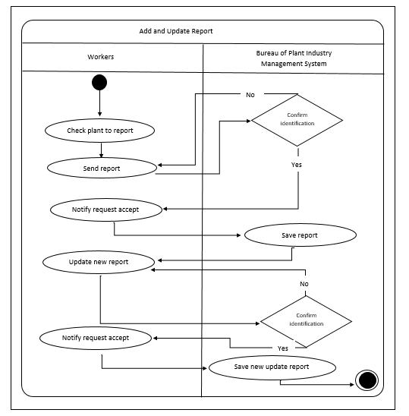 Activity**

*Figure 5: Manage Report Activity Diagram*

Figure 5 show the activity of workers where the process of monitoring plant report. The workers will check, add, update report if have a new plant report and send to the server.

**Manage Plant Activity**

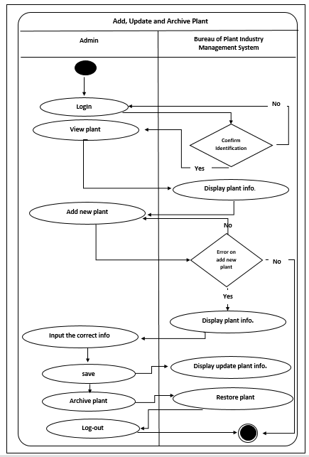

*Figure 6: Manage of Plant Information Activity Diagram*

Figure 6 show the process of activity of admin where the plant is monitor. The admin will check, add, update new plant and save to the database.

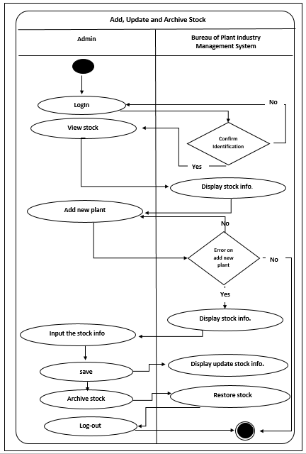**Manage Stock**

*Figure 7: Activity Diagram Manage Stock*

Figure 7 show the process of managing the stock. The admin will add, update and archive stock and save to the database.

**Customer Buy Product**

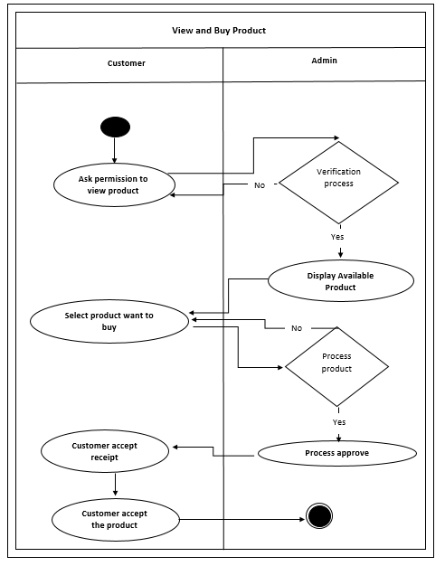

*Figure 8: Activity Diagram Customer Buy Crops*

Figure 8 show on how the process of customer buy a crops harvested. The customer ask permission if have an available product to buy. The admin will show all crops product and after the customer choosing the product, admin will process the transaction and give receipt after the customer buy a crops.

**Decomposition Chart**

Decomposition chart show the break down process and its sub-processes to organized step by step procedure of the whole system.

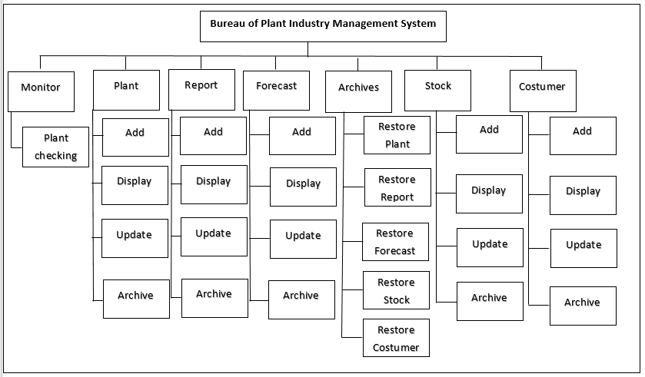

*Figure 9: Decomposition chart of Bureau of Pant Industry Management System*

Decomposition chart show the break down process and its sub-processes to organized step by step procedure of the whole system. Every process is being labelled and equate the functionality of the whole system.

**Entity Relationship Diagram**

Rational database management system (RDMS) is a database management system (DMS) based on the relationship model of data. In conformity, the entity relationship diagram shows the relationship and connection of all tables in the database in a working system.

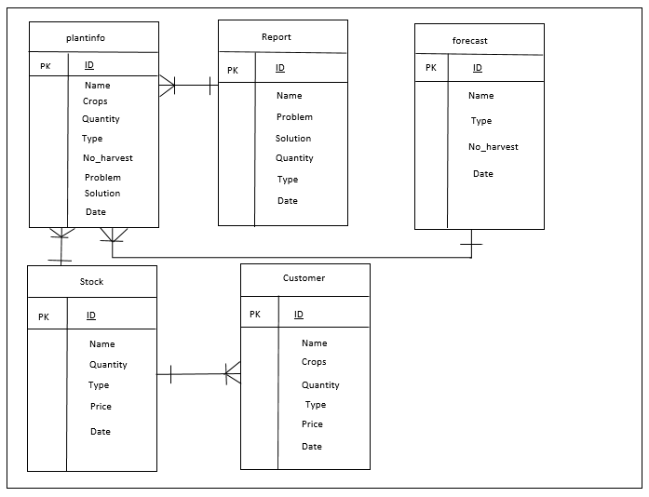*Figure 10: Entity Diagram of Bureau of Plant Industry Management System*

Figure 10 show all connection of all the table in database. Each table require specific information about the plants and costumer data that been store in order to work the system.

**Screen Lay-out and Design**

**Home**

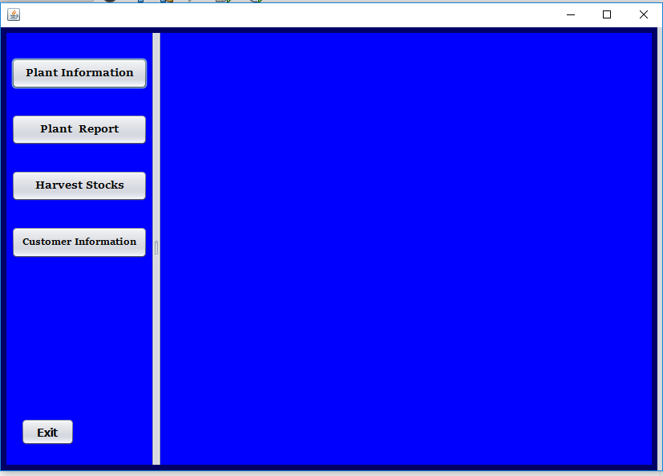

*Figure 11: Home page*

Figure 11 shows the home page which can be accessed can accessed by the administrator. Add and update is usable for this page.

**Plant Table**

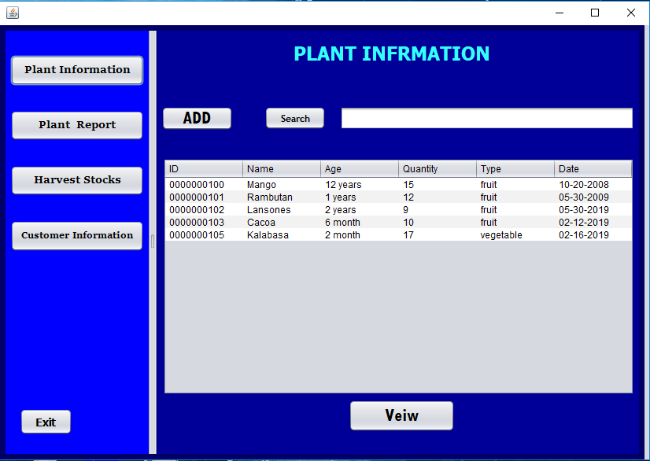

*Figure 12: Plant Information*

Figured 12 show the plant information of the system. The admin is input data to add and update of data.

**Report Table**

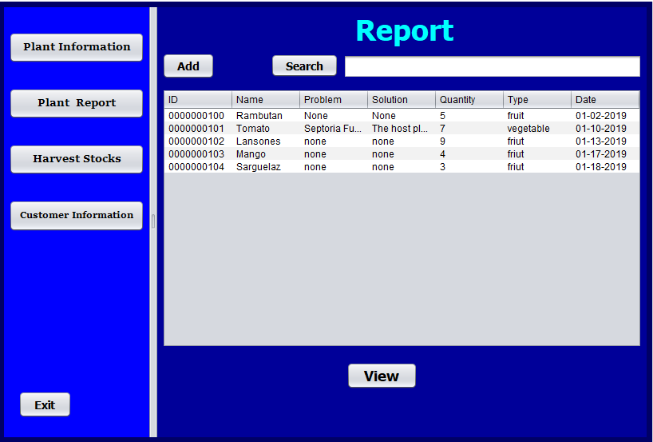

*Figure 14: Plant Report*

Figure 14 show the table in report. Admin will monitor and update new report that been send by the workers.

**Harvest Table**

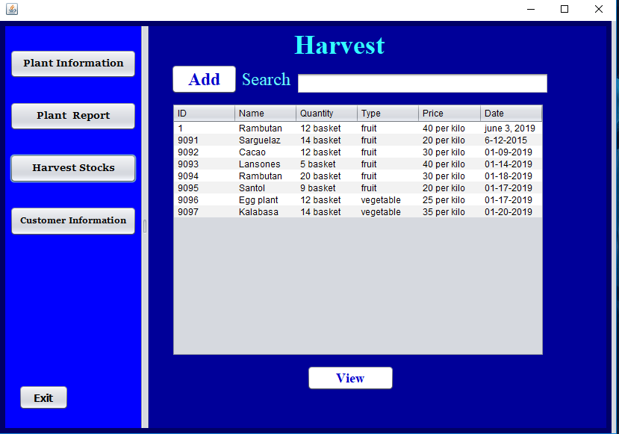

*Figure 15: Plant Harvest Stock*

Figure 15 show the table in plant harvest stock. Admin is able to add and update new crops harvest when new crops is arrived.

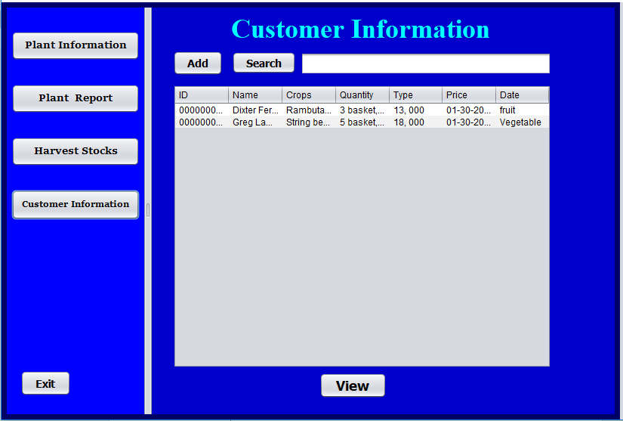

*Figure 16: Customer Information*

Figured 16 show the table of customer data. Admin is able to add and update new customer that want to buy crops of BPI.

**Architectural Framework**

Architectural Framework show the system’s overall process that starts with giving all the data of workers report on plant problem and the customer information. The administrator will have gathered all the information retrieved from the store in the database. After recording, monitoring of data will conduct to support the report of workers in terms of problem in plant to support a solution. The administrator will also accept record of plant harvest and reservation of customer to buy crops harvested.

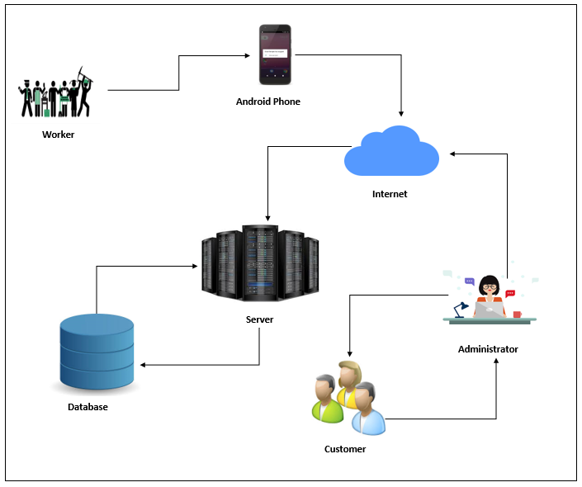

*Figure 17: Architectural Framework of Bureau of Plant Industry Management System*

Figure 17 shows on how the process of system work. Workers is the one who gathered information and use android device to monitor plant and give report to the plant problem then send to the server. The function of server is to accept the data and store in the database, it also shows the content of database that they need. The administrator will monitor and add, update data when have a new plant arrived and new customer. The administrator will also input harvest crops to the system to give information on the customer. The customer will view and buy only a crops if have available and sufficient to their needs.

**System Testing and Implementation**

To prove that the system is reliable in the terms of the output information produced by the system, the system should be test to figure out it effectiveness in work. The proponent tested the system to prove that the system is accurate in monitoring all data in plants and customer. The proponent gathered some individuals to act as the workers and customer to re-evaluate the process

of the system to reach their main goal to lessen the task and burden of the staff.

**Bureau of Plant Industry Management System**

This inventory system provides the following feature that is commonly done in their transaction processes as well as the recording of data’s.

* Provide an android application monitoring in plant report.
* Accurate data gathered based on the plant report.
* Provide a best support in terms of plant solution to the given problem.
* Use a specific information on the crops harvested on the customer.
* Protect the data of the plant and customer information by means of storing in the database.
* Provide an automated report about in plant and customer data.

**Recommended Hardware Specification**

For Bureau of Plant Industry Management Systemis develops and run in a perfect function, but first the client must implement the following hardware specifications:

Microsoft Window 7 Professional/Windows 8/ Windows 8.1

* 2 GB (32-bit), 4 GB (64-bit)
* GB of free disk space

Printer

**Recommended Software Specification (Workstation)**

* Windows Server 2008 Enterprise Edition
* MySQL, Apache
* A Backup Utility Software
* MySQL database MySQL Utilities
* Java

**Data Dictionary**

The table below show all the list of all table and the data store in the database on the Bureau of Plant Industry Management System. It provides the attribute, data type and also the description of each fieldname to recognize the data being stored in the databased.

Table 9: plantinfo

|  |  |  |  |
| --- | --- | --- | --- |
| Fieldname | Description | Type | Length |
| ID | Plant Identification | INT | 10 |
| Name | Plant Name | VARCHAR | 50 |
| Type | Type | VARCHAR | 50 |
| No_harverst | No_harvest | VARCHAR | 50 |
| Problem | Problem | VARCHAR | 50 |
| Solution | Solution | VARCHAR | 50 |
| Quantity | Quantity | VARCHAR | 50 |
| Date | Date | VARCHAR | 50 |

Table 10: report

|  |  |  |  |
| --- | --- | --- | --- |
| Fieldname | Description | Type | Length |
| ID | Plant Identification | INT | 10 |
| Name | Plant Name | VARCHAR | 50 |
| Problem | Problem | VARCHAR | 50 |
| Solution | Solution | VARCHAR | 50 |
| Quantity | Quantity | VARCHAR | 50 |
| Type | Type | VARCHAR | 50 |
| Date | Date | VARCHAR | 50 |

Table 11: forecast

|  |  |  |  |
| --- | --- | --- | --- |
| Fieldname | Description | Type | Length |
| ID | Plant Identification | INT | 10 |
| Name | Plant Name | VARCHAR | 50 |
| Type | Type | VARCHAR | 50 |
| No_harvest | Number of Harvest | VARCHAR | 50 |
| Date | Date | VARCHAR | 50 |

Table 12: stock

|  |  |  |  |
| --- | --- | --- | --- |
| Fieldname | Description | Type | Length |
| ID | Plant Identification | INT | 10 |
| Name | Plant Name | VARCHAR | 50 |
| Quantity | Quantity | VARCHAR | 50 |
| Type | Type | VARCHAR | 50 |
| Price | Price | VARCHAR | 50 |
| Date | Date | VARCHAR | 50 |

Table 13: costumer

|  |  |  |  |
| --- | --- | --- | --- |
| Fieldname | Description | Type | Length |
| ID | Plant Identification | INT | 10 |
| Name | Customer Name | VARCHAR | 50 |
| Crops | Quantity | VARCHAR | 50 |
| Quantity | Type | VARCHAR | 50 |
| Type | Type | VARCHAR | 50 |
| Price | Price | VARCHAR | 50 |
| Date | Date | VARCHAR | 50 |

**Gantt Chart**

Gantt chart describes the overall activities in developing the system and application. This chart guides the proponent to managed time by recording the event occur during and after the process. This chart shows the measurement of length or how long it takes when doing the process of the system and application. By this Gantt chart, it is easy to figured out the delivery time of the proposed project.

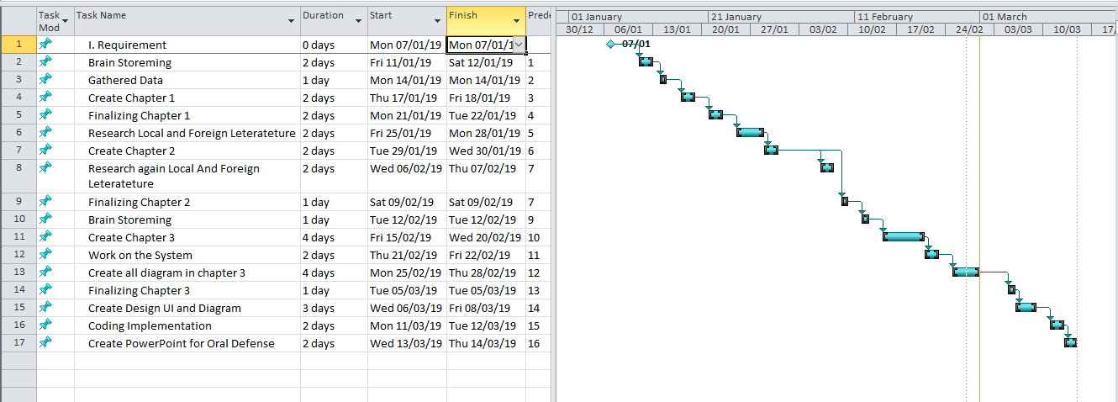

**Time Table**